November 18th, 2019
Introduction
This submission is prepared for FRSA’s SAC meeting with the Board of Directors scheduled November 25th, 2019. In my capacity as a SAC member on Health Service Providers, I have reached out to the Ontario Association of Speech-Language Pathologists & Audiologists (OSLA) and the College of Audiologists and Speech-Language Pathologists of Ontario (CASLPO) and colleagues in the Auto Insurance Industry to obtain input subsequent to the SAC meeting with management on November 12th, 2019.
I note that the opinion in this submission is my own as a Speech-Language Pathologist and certified Life Care Planner who owns KIDSPEECH. Since 1988, the clinic has provided assessments and treatment services to both children and adults with various communication problems such as articulation, language, memory, reading/writing and cognitive-communication skills to name a few of the problems we work with. We also prepare life care plans and provide services in the auto insurance sector such as assessments, treatment, independent examinations and paper file reviews.
Purpose & Approach
This submission will provide some feedback on various aspects in the priorities, budgets and approach in the regulated sectors within the timeframe provided.
I have relied on several past submissions, acquired knowledge and experience over the decades in the field dating back to prior to introducing HCAI and licensing with FSCO.

FSRA’s 2019-20 Priorities-
These 2019-20 priorities were outlined in the document prepared by FSRA dated November 12th, 2019. For the purpose of this submission I will focus on the regulatory effectiveness sections 2.1, 2.2, 2.3, 2.4 and 2.5 focused on sections 3.1, 3.2, 3.3 and 3.4 on Auto Insurance as follows:

2.1 Protect the public interest
This was addressed in the document prepared for the Deputy Minister Mr. Steve Orsini in 2012. The Steering Committee for Ontario Automobile Insurance Anti-Fraud Task Force prepared a full report (132 pages) dated November 2012 wherein it starts with the following excerpt.

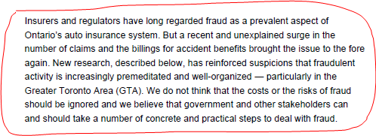

In this document, they outline the fact that ” there is ‘no silver bullet’ that will effectively eliminate fraud.” Auto Insurance includes everybody. They stated that the government should lead the fight against fraud but that all Ontarians play a role. Everybody includes, the Insurance industry, the Ministry, the regulatory bodies, consumers, legal representation, The Coalition, HCAI, health care systems, FSRA and repair and collision shops.
On page 84 in this document, there were recommendations for Regulated Health Colleges:
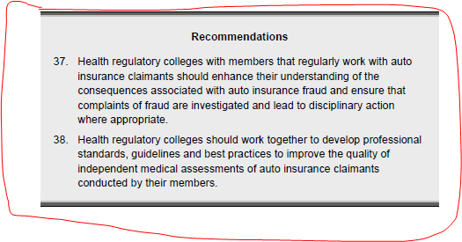

At the time, the Task Force had a meeting with the Federation of Health Regulatory Colleges of Ontario (FHRCO) in January 2012. It was explained that the Federation’s major preoccupations of the colleges were about priorities and focus which may not be the same for all colleges. In 2012 there were 21 self-governing health professions. Today there are 26 regulatory colleges which regulate 29 distinct professions. For example, our college regulates two distinct professions: Speech-Language Pathologists and Audiologists. The regulatory burden for the Federation is clearly increasing making handling priorities and focus more complex.
Additionally, it is worth noting that cracking fraud in Ontario has been in place since 1998.
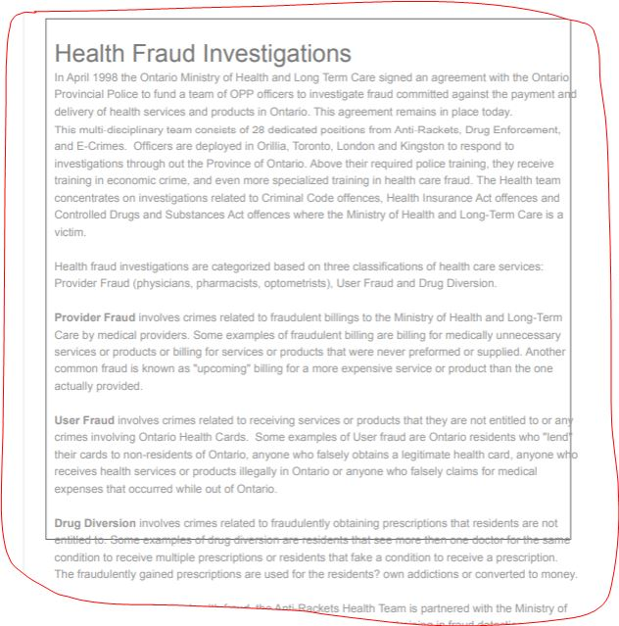
While it is important not to duplicate information, it is important to exchange information. Some change and some influence can occur over time if colleges can continue to communicate and exchange with FRSA together with their respective associations with the inclusion of expertise. Since September 2019, 10 colleges in the Federation have begun the process to work collaboratively with FRSA. CASLPO is one of them. This collaboration would certainly assist with the burden reduction as noted in the 2019-20 priorities. FSRA should aim to rely upon health providers who have used the system for an extensive period to drive decisions such as establishing

services standards for delivering meaningful services such as independent examinations. While this submission will not focus on this specific topic, I do believe it is important to direct the readers to the work done by Dr. Pierre Côté and his team who put forth a large document (279 pages) entitled “Enabling recovery from common traffic injuries: a focus on the injured person”. This management protocol was a collaboration of several experts who focused on the period of 0-3 months post injury. In this vital period, the injured is assisted to return to their pre-accident life. Unfortunately in this document the roles of a Speech-Language Pathologist or an Audiologist were not included. The focus in this document was to the physical and emotional injuries versus cognitive communication problems which may or may not be evident in this period.

They discussed pre-approved framework guidelines which are outlined on page 26.

I bring forth that it is important to note that injured children should be given attention differently from injured adults in any diagnostic and treatment care plan in auto Insurance. One way may be to consider a pre-approved fund for the purpose of making it an available care plan to children. This can also be adapted to adults. A pre-approved framework may reduce the burden on adjusters while offering the consumer with the required care at the right time! We all know that when the burden is reduced, costs can be reduced too if measures based on evidenced base practice guidelines are in place.

This aforementioned document is comprehensive and could be used as another instrument to rely upon.

2.2 Increase sectoral expertise
This is of paramount importance together with conflict of interest.

2.3 Enable innovation
I propose the following:
The ABCs moving forward for Children & Adults
A. Online OCFs and invoicing – RIP
Improve these forms by eliminating redundant data/ information to ultimately make it user friendly for all parties.
- Reduce the footprint of paper trail, reduce costs and possibly eliminate live support to address system problems.
- Invite registered health professionals who have used the system over the past 2 decades to contribute and to offer insight.
- Provide modules and/or live workshops which need to be provided before new documents are introduced for use in a timely fashion.
Amen
B. Speech-Language Pathologist services
Pre-authorized visits with a registered Speech-Language Pathologist during the first 3 months post injury to screen, assess, prepare a report and design a plan. Services are both direct and indirect with client, school/ teachers, family or employer/ work and work with optometrists and audiologists to address dizziness, visual & hearing problems/ sensitivities because these are common sequelae in concussions (can happen in whiplashes). This will improve outcome in concussions, and ABI for both children, youths, and adults/ seniors.
- Timely access to services for all Ontarians available to both insured and underinsured children and adults.
- A treatment plan must be submitted following 90 days if continued services are required.
C. Review fees for service delivery provided by registered health professionals.
Ontarians deserve to choose & access services from registered health professionals whether these are Independent Examinations, Consultations, Assessments, Treatment, etc within their communities from experienced registered health professionals. Many, however, are no longer providing services to clients under auto insurance because of the complexity and the adversarial nature of the system.

2.4 Enhance stakeholder collaboration, & 2.5 Modernize systems and processes
Stakeholders can assist to provide guidance to the board. These individuals could also be relied upon by other regulatory bodies such as colleges, the Federation and professional associations to assist at various intervals as FSRA implements new models and porcesses.

Summary
While the focus of FRSA is ‘consumer first’, it is important to find measures to increase consumer literacy for Ontarians whether it be auto insurance, home insurance or any other type of product. All, too often, we know, cost drives choices!

